Practical 1

What is Cloud Computing?  
  
Cloud computing refers to the delivery of computing services over the internet, allowing users to access and utilize computing resources such as servers, storage, databases, networking, software, and more, on-demand and as a service. Instead of owning and maintaining physical infrastructure or servers, users can rent or lease these resources from a cloud service provider on a pay-as-you-go basis.

The key characteristics of cloud computing include:

1. **On-Demand Self-Service**: Users can provision computing resources as needed without requiring human intervention from the service provider.
2. **Broad Network Access**: Cloud services are accessible over the internet from various devices such as laptops, smartphones, and tablets.
3. **Resource Pooling**: Computing resources are pooled together to serve multiple users, with different physical and virtual resources dynamically assigned and reassigned according to demand.
4. **Rapid Elasticity**: Cloud resources can be rapidly and elastically scaled up or down to accommodate changes in demand. This scalability ensures that users only pay for the resources they use.
5. **Measured Service**: Cloud computing resources are metered, allowing users to monitor and track their usage, and enabling providers to optimize resource allocation and billing.

Cloud computing offers several deployment models, including public cloud, private cloud, hybrid cloud, and multi-cloud, catering to different needs and preferences. Public cloud services are provided by third-party providers over the internet, while private clouds are dedicated to a single organization and can be hosted on-premises or by a third-party provider. Hybrid clouds integrate resources from multiple cloud environments, while multi-cloud strategies involve using services from multiple cloud providers.

Some common examples of cloud computing services include Infrastructure as a Service (IaaS), Platform as a Service (PaaS), and Software as a Service (SaaS). In IaaS, users rent virtualized infrastructure resources such as virtual machines, storage, and networking. PaaS provides a platform allowing developers to build, deploy, and manage applications without worrying about underlying infrastructure. SaaS offers software applications hosted and maintained by a third-party provider, accessible over the internet on a subscription basis.

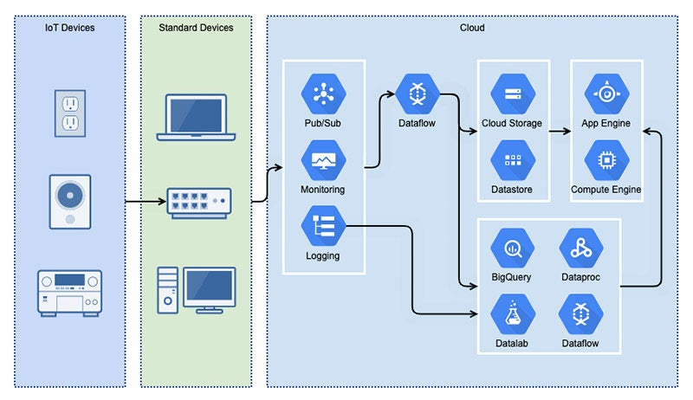

Features of Cloud Computing   
  
Cloud computing encompasses a range of features and capabilities that distinguish it from traditional computing models. Some of the key features of cloud computing include:

1. **On-demand self-service**: Users can provision computing resources such as servers, storage, and networking capabilities as needed, without requiring human intervention from the service provider.
2. **Broad network access**: Cloud services are accessible over the internet from a variety of devices, including desktop computers, laptops, tablets, and smartphones.
3. **Resource pooling**: Cloud providers aggregate computing resources to serve multiple customers, allowing for efficient resource utilization and economies of scale. Customers typically share a pool of computing resources, but these resources are dynamically assigned and reassigned according to demand.
4. **Rapid elasticity**: Cloud services can quickly scale up or down to accommodate changes in demand. This allows users to access additional resources during peak usage periods and release resources when they are no longer needed, helping to optimize cost and performance.
5. **Measured service**: Cloud computing resources are typically metered, allowing users to pay only for the resources they consume. This pay-as-you-go model enables cost-effective resource usage and provides transparency into resource usage and costs.
6. **Multi-tenancy**: Cloud infrastructure supports multiple users or "tenants" sharing the same physical resources while maintaining isolation between them. This enables efficient resource utilization and helps providers achieve economies of scale.
7. **Scalability**: Cloud computing offers the ability to scale resources horizontally (adding more instances of a resource) or vertically (increasing the power of existing instances) to meet changing demand. This scalability helps ensure that applications can handle varying workloads effectively.
8. **Fault tolerance and reliability**: Cloud providers typically offer high levels of redundancy and reliability to ensure that services remain available even in the event of hardware failures or other disruptions. This includes features such as automatic failover, data replication, and geographic redundancy.
9. **Security**: Cloud providers implement robust security measures to protect data and infrastructure from unauthorized access, data breaches, and other security threats. This may include encryption, identity and access management, network security controls, and compliance certifications.
10. **Flexibility and agility**: Cloud computing enables organizations to quickly deploy and iterate on applications and services, reducing time-to-market and enabling faster innovation. This agility allows businesses to respond more effectively to changing market conditions and customer needs.
11. **Google Cloud**: Google Cloud is a suite of cloud computing services provided by Google, including infrastructure as a service (IaaS), platform as a service (PaaS), and software as a service (SaaS) offerings. It provides a range of services for computing, storage, networking, machine learning, data analytics, and more, allowing businesses to build, deploy, and scale applications and services on Google's infrastructure.
12. **Microsoft Azure**: Microsoft Azure is a cloud computing platform and services offered by Microsoft. It provides a wide range of cloud services, including computing, storage, databases, networking, artificial intelligence (AI), Internet of Things (IoT), and more. Azure enables businesses to build, deploy, and manage applications and services across a global network of data centers, leveraging Microsoft's expertise in enterprise software and services.
13. **Amazon Web Services (AWS)**: Amazon Web Services (AWS) is a comprehensive cloud computing platform provided by Amazon. It offers a broad set of cloud services, including computing power, storage, databases, machine learning, analytics, security, and more. AWS allows businesses to access scalable and cost-effective computing resources on demand, enabling them to innovate quickly and scale their applications and services globally.

These three cloud providers are among the largest and most widely used in the industry, each offering a rich set of features and services to meet the diverse needs of businesses and organizations.

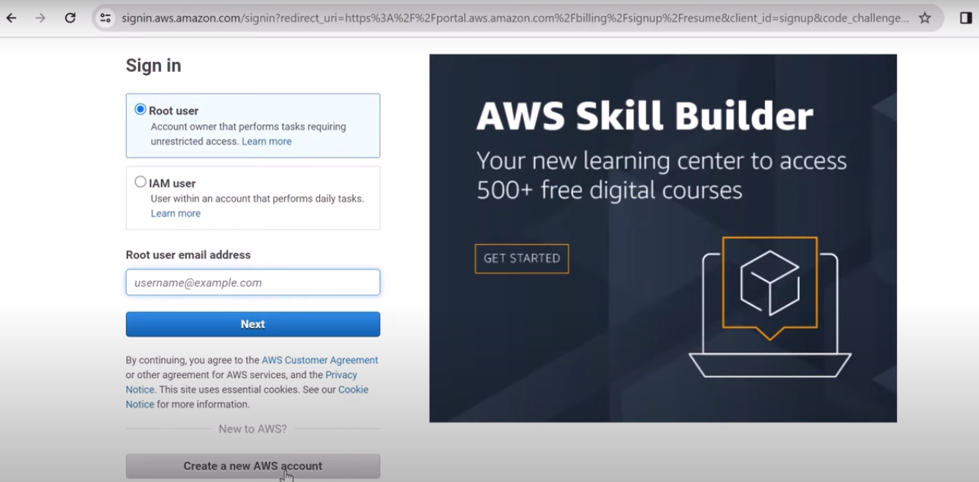  
Signing Up for the Amazon AWS   
  
The steps for signing the Amazon AWS are:

1.Open AWS signing page in your favourite browser.

2.Enter your email address and User Id Name.

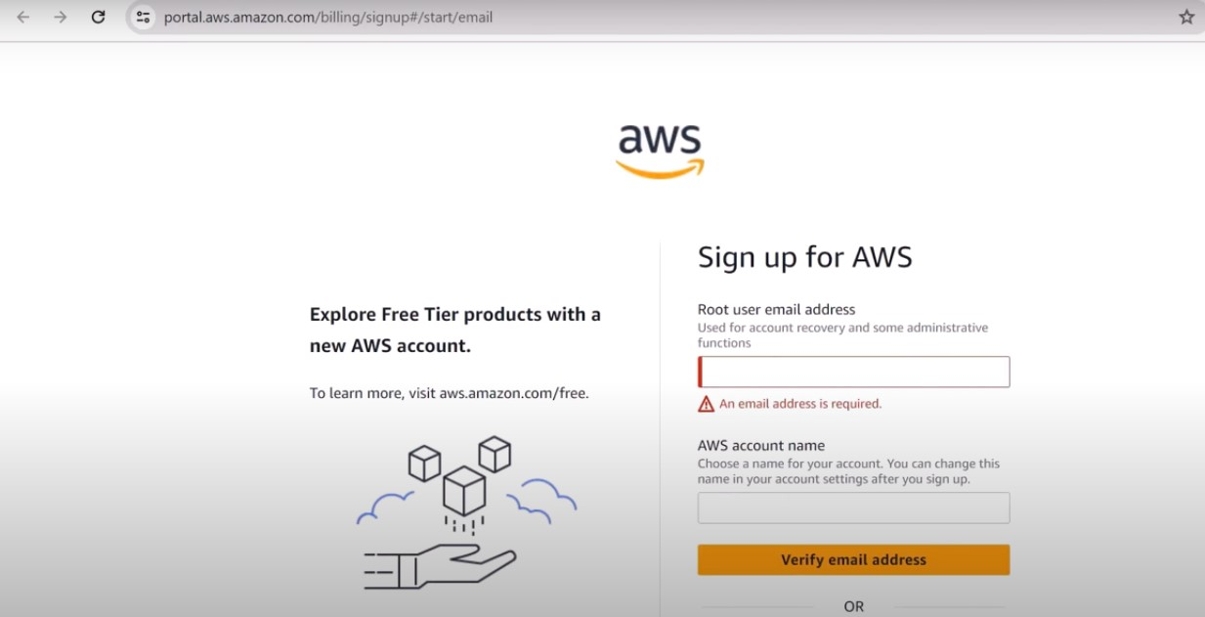

3.Enter your verification code.

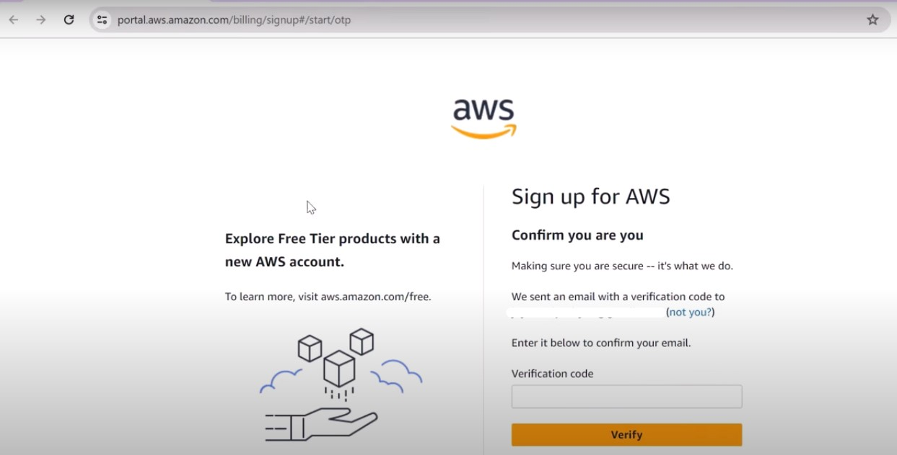

4.Verify Your Email with the Code

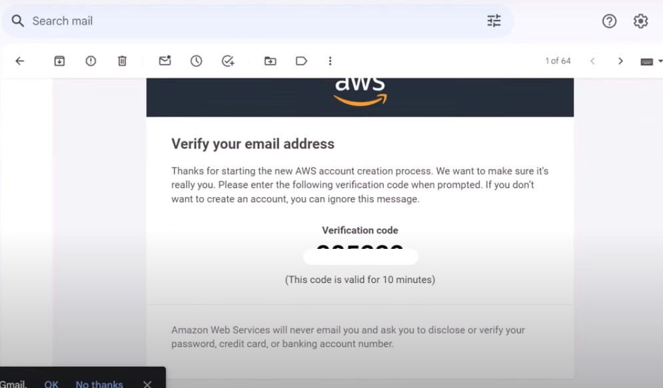

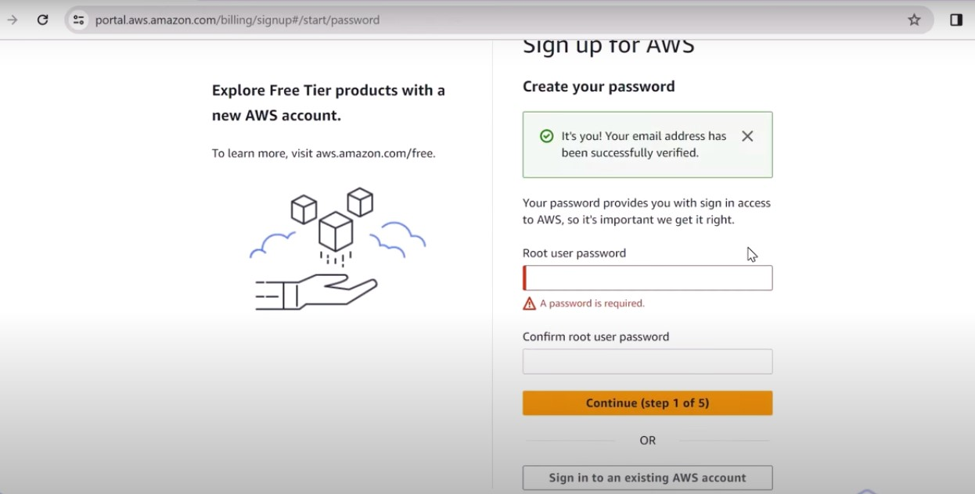5.Set up your password

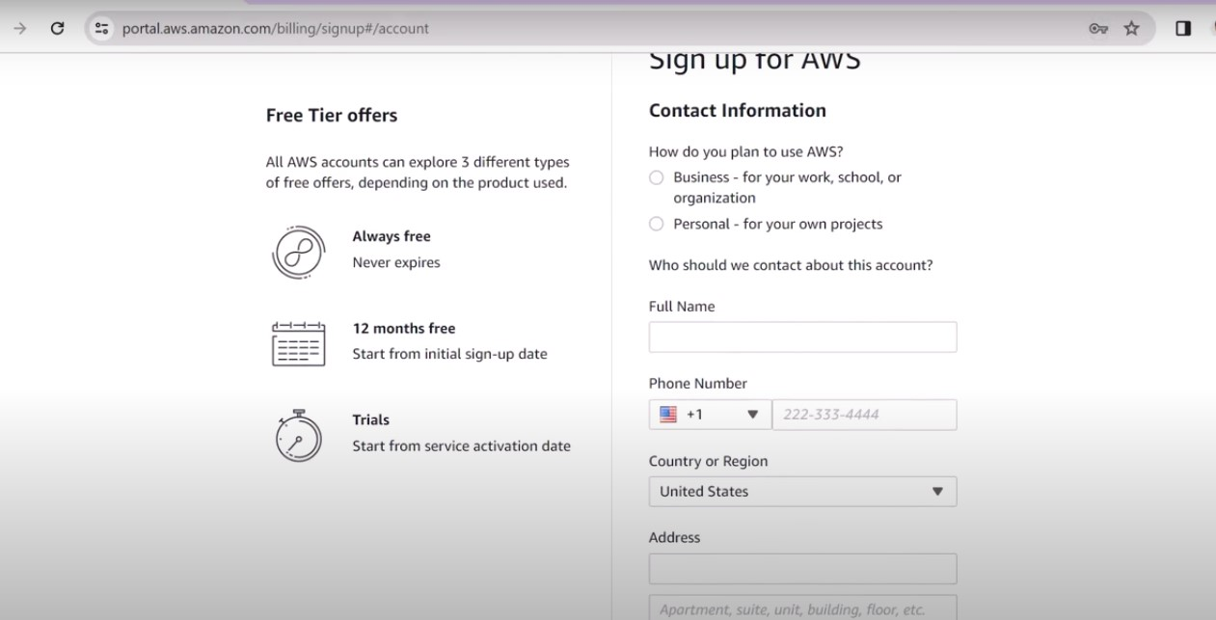6.Enter your Contact Information

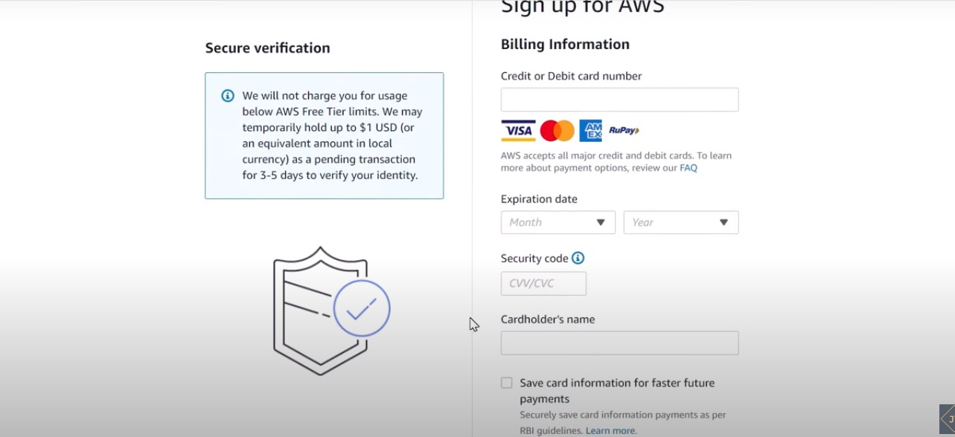7.Enter your Billing Details.

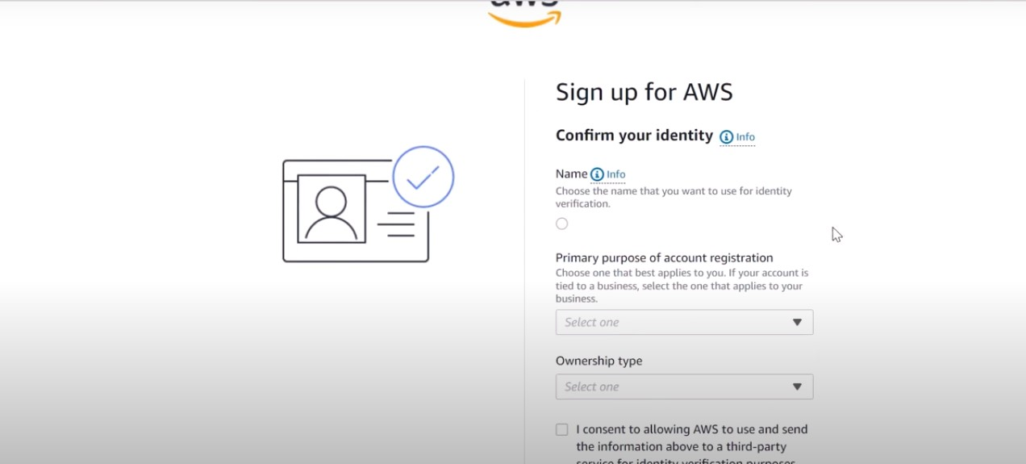8.Confirm your Identity.

9.Enter OTP and Confirm your Identity.

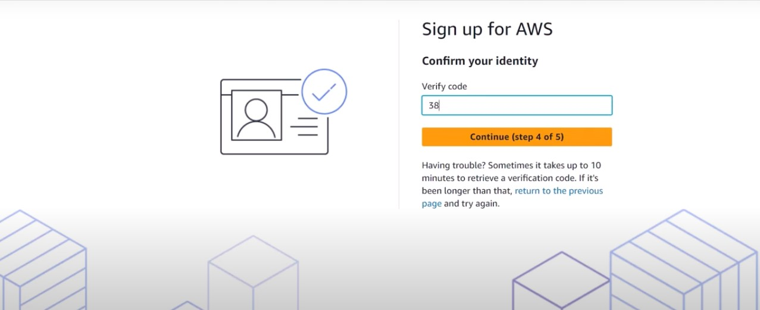

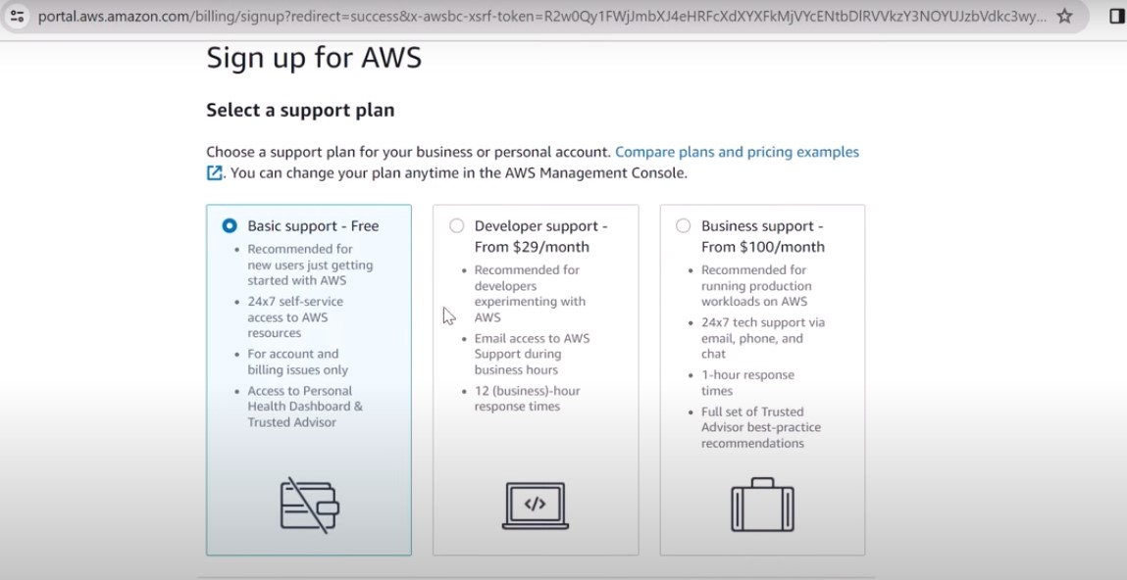10.Select a Support Plan.

11.Welcome to AWS.  
